Miro Web Audit
Miro is a virtual whiteboard that can be used for cross collaboration and getting ideas across. Teams can have shared Miro boards and can add notes, ideas, and other items to the board.

Keyboard Navigation
Miro allows users to access their software using keyboard navigation. Users are able to tab through and use arrows.
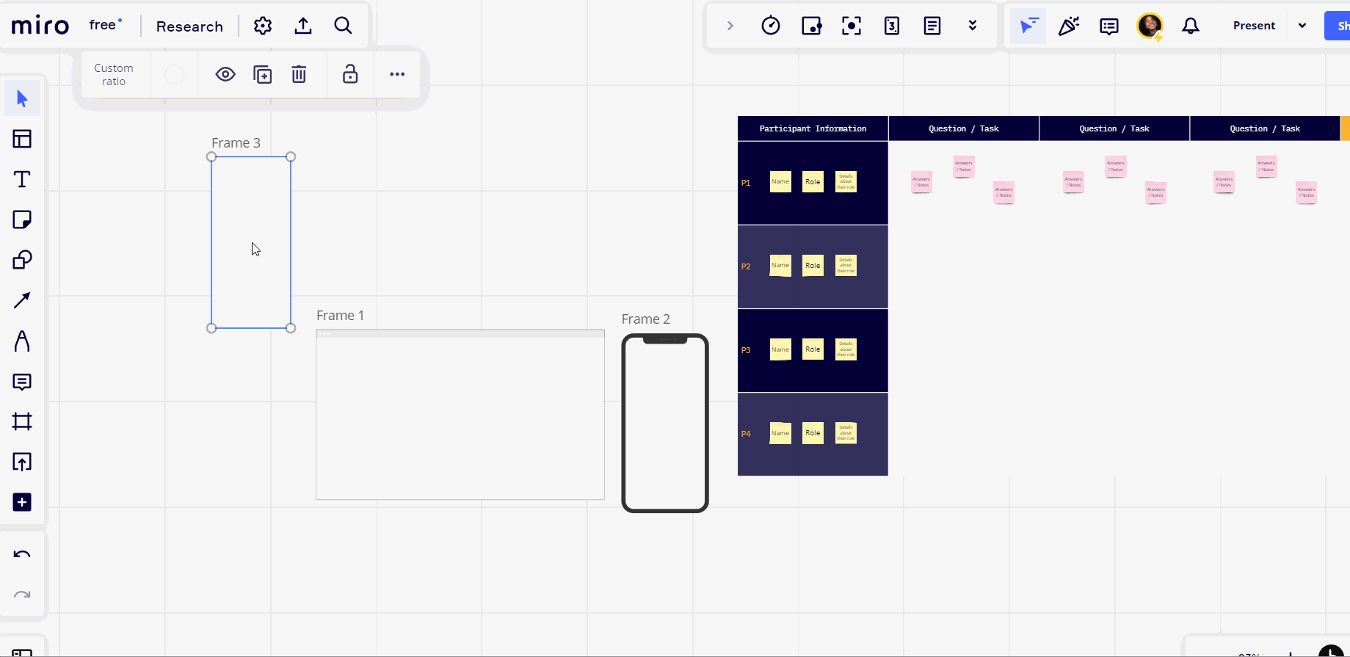

There are also shortcuts that allow users to receive accessibility help, give accessibility feedback, enable screen reader mode, and/or navigate to the first widget on the page.
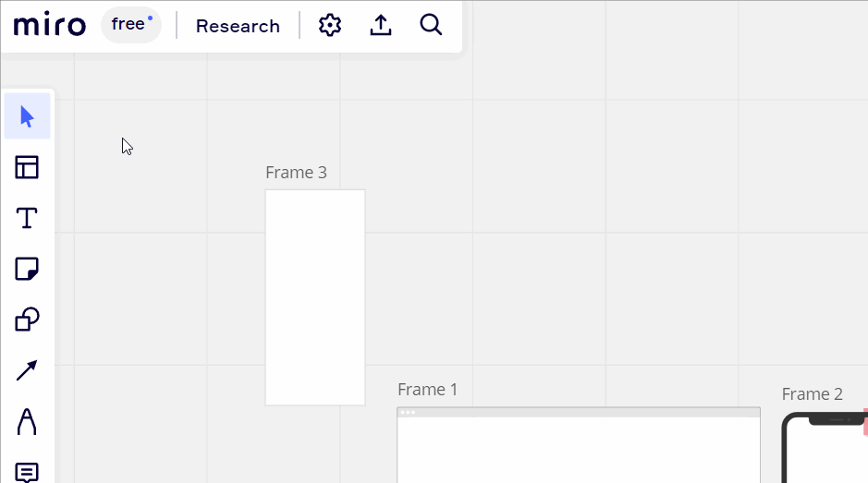

Screen Reader Mode

Alternative Text
Alternative text is available on Miro. Once a photo is uploaded, there is an option to add alternative text next to the resize, crop, and replace image options. (can developers still see it if it’s shared)

Color Contrast
Miro seems to follow the color contrast WCAG guidelines for the majority of the site. Because of this, we are unable to tell is Miro alerts users of low color contrast.

Light Sensitivity
Miro doesn’t have a dark mode like other softwares. However, individuals with light sensitivities are able to create a frame with a darker background and work on that instead. An example is demonstrated in the gif below.
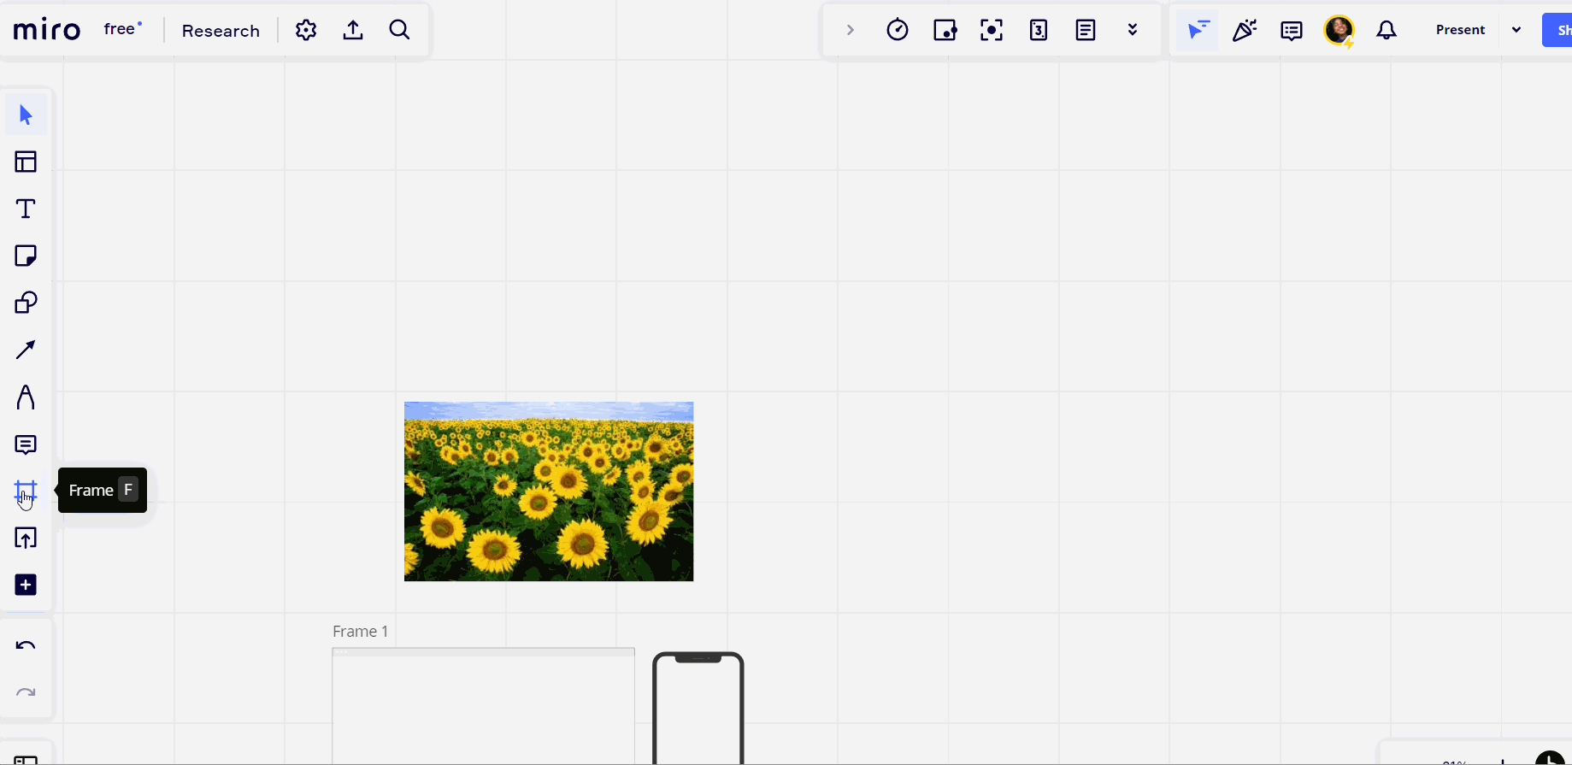

Audit Results
Miro appears to be a software used for notes and ideas rather than for webpage and other frame designs. Although Miro itself has accessible features such as a screen reader mode and adequate keyboard navigation, it is not the best at suggesting best practices. Miro doesn’t have any pop ups or alerts for accessibility suggestions such as color contrast warnings or a visible alert to add alternative text to images.

